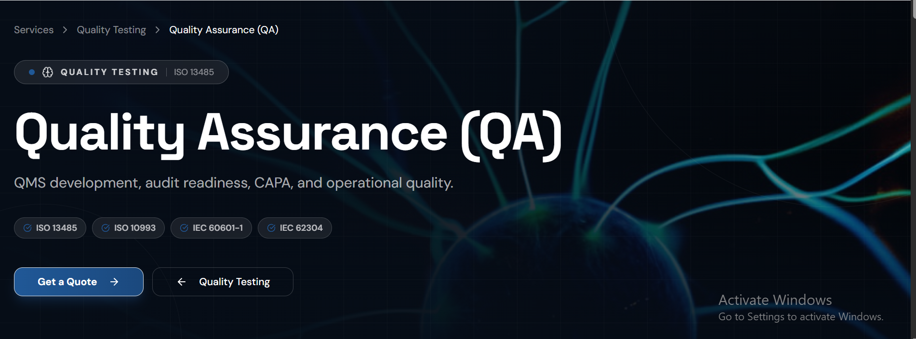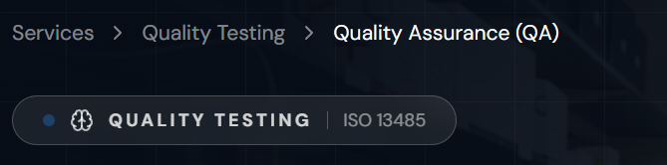
I don’t think writing “Quality Testing” as a main branch is suitable for Quality Assurance. QA is not a sub domain of Quality Testing.
For standards listed, they are product standards except ISO 13485 (please write it as ISO 13485:2016). Instead QMSR (FDA 21 CFR 820), ISO 14971:2019 would be better suited.
Just a suggestion, you can add keywords like FDA, QMSR, MDSAP, Risk Management, Quality Management System (or QMS).
- SERVICE OVERVIEW
For Service Overview, I think it would be better to structure it as a pitch e.g.
Leverage our proven quality expertise to build, strengthen, and maintain compliant quality systems. Having successfully established and maintained an ISO 13485-certified Quality Management System and passed regulatory audits, our team supports medical device manufacturers with QMS development, design & development support, audit readiness, CAPA management, document control, trainings, product release, and continuous improvement initiatives.
- KEY FEATURES
ISO 13485 QMS design (replace design with development & Implementation)
Please add “Compliance Support, Documentation Services, Design & Development Support, Complaint Handling & Investigation Support, Training & Awareness Programs, Validation & Qualification Support”
- PERFORMANCE
Key Metrics section doesn’t related to QA. Instead you can define our achievements such as:
- Successfully established and maintained an ISO 13485-certified Quality Management System
- Successfully completed regulatory audits and inspections
- Comprehensive quality processes covering design, manufacturing, documentation, and other support activities
- Structured CAPA, document control, and change management systems
- Commitment to continuous improvement and regulatory compliance

- DELIVERABLES
Add the following:
- Replace QMS Documentation with ISO 13485-aligned QMS documentation
- Except for audit reports (write Audit plans, checklists and reports)
- Quality Trainings
- Quality Metrics & Data Trending
- Design & Risk Management Documentation
- Improvement Recommendations
- COMPLIANCE & STANDARDS
The heading “Built for Regulated Healthcare Software” again sounds more aligned with software end. Instead, “Built for Medical Device Quality & Compliance” can be used.
Again the standards used are for testing (except for ISO 13485 & ISO 14971). Please write the following:
- ISO 13485:2016
- QMSR (FDA 21 CFR 820)
- ISO 14971:2019
- DRAP Compliance
- OUR APPROACH
The “Our Approach” section seems more aligned with SQA services. For QA we can use the approach:
- Understand
(We assess your current quality processes, documentation, and compliance status).
- Design
(We develop scalable quality solutions tailored to your organization and regulatory needs).
- Implement
(We work alongside your team to establish effective quality processes and documentation).
- Improve
(We support continuous improvement through audits, CAPA management, training, and ongoing quality oversight).
- Full-service Offering
If this section refers to the entire Quality department services it seems okay but if it’s QA specific please change it to the following:
- ISO 13485 QMS & Audit Readiness
- Production Quality & Process Controls
- Software Quality (SaMD / SiMD)
- Design Controls & Verification Support
- Risk Management & Compliance
- Production & Testing Support
Our QA services are designed to help organizations build robust quality systems, achieve regulatory compliance, improve operational performance, and maintain high standards of product quality and safety. We partner with clients to provide practical, efficient, and reliable quality assurance solutions tailored to their business needs.

